Airline Data Injestion
- 1 dimention table(table containg text) of Airport codes.
- On dailty basis, in s3 the data will come in hive style partition.

What services will we be using:
1. s3 as our datalake
2. Event bridge rule: Amazon EventBridge is a service that helps different applications talk to each other by passing messages (called "events"). Think of it as a messenger that delivers important notifications between different services in AWS or even your own custom applications. It enables you to build event-driven applications.
3. Step function - for orchestration
4. Step function - create workflows, also called State machine
5. Glue crawler
6. Glue job
7. Redshift as datawarehouse
8. SNS for notifications

Workflow/Architecture:
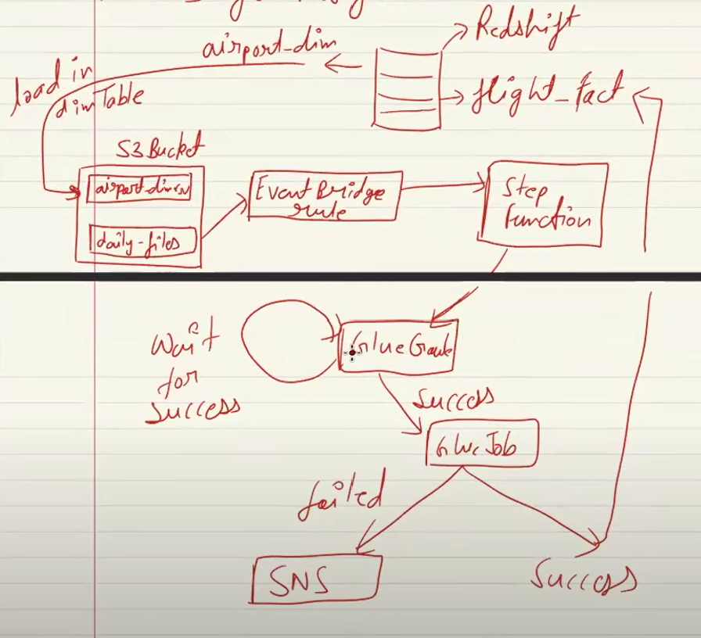

1. Redshift Database:
What is it?
- Amazon Redshift is like a big filing cabinet for your data. It’s designed to store large amounts of information and make it easy to analyze.
Why are we using it?
- To store the final, processed data in an organized way, so we can run queries and analyze it efficiently (e.g., for reporting or visualization).

2. S3 Bucket Connected to EventBridge:
What is it?
- S3 Bucket: This is like a digital locker where you upload your raw files (e.g., CSV, JSON).
- EventBridge: This acts as a messenger. When something happens in the locker (e.g., a file is uploaded), it notifies the system that action is needed.
Why are we using this?
- S3 stores raw data, and EventBridge ensures that any new file triggers the next set of actions automatically (so you don’t have to do it manually).

3. Step Function:
What is it?
- A step function is like a flowchart that automates and organizes the sequence of steps to be performed.
Why are we using this?
- To make sure all the steps (triggering Glue Crawler, Glue Job, notifications) happen in the right order and handle success/failure logic.

4. Glue Crawler:
What is it?
- Think of it as a data scanner. It checks the files in your S3 bucket and automatically figures out the structure of the data (e.g., column names, data types).
Why are we using this?
- To catalog the raw data and make it ready for processing by creating a schema (like a blueprint of the data).

5. Glue Job (Joining Operation):
What is it?
- A Glue Job is a data worker that processes the data.
- In this case, it performs a join operation, meaning it combines different pieces of data from multiple files or sources into one complete dataset.
Why are we using this?
- To clean, transform, and prepare the data for final storage in Redshift. For example, if one file contains customer names and another file contains orders, the Glue Job combines this information into a single dataset.

6. Notifications for Glue Job Failure:
What is it?
- If the Glue Job fails (e.g., due to an error in the data or code), a notification is sent to you (via email, SMS, etc.).
Why are we using this?
- To know immediately when something goes wrong so you can fix it without delay.

7. Data Sent to Redshift DB (if Glue Job is Successful):
What is it?
- Once the Glue Job completes successfully, the final cleaned and transformed data is loaded into the Redshift database.
Why are we using this?
- To store the data in a central location optimized for querying and analysis, such as running reports or visualizing data in tools like Tableau or QuickSight.

Full Workflow in Layman Terms:
- Raw Data Upload:
You upload raw files (e.g., sales data or customer data) to the S3 bucket.
- EventBridge Notification:
EventBridge detects the new file in S3 and notifies the system.
- Step Function Starts:
The step function orchestrates the following steps in sequence:
  - Step 1: Trigger Glue Crawler to analyze and catalog the data.
  - Step 2: If the crawler completes successfully, trigger the Glue Job.
- Glue Job Processes Data:
  - It joins multiple datasets or cleans the data to prepare it for use.
- Handle Success/Failure:
  - If the Glue Job fails, a notification is sent to alert you.
  - If it succeeds, the final data is sent to the Redshift database.
- Final Data in Redshift:
  - Your transformed and clean data is now stored in Redshift, ready for analysis or reporting.

Why This Approach?
- Automation: The entire process runs automatically when new data arrives in S3.
- Scalability: Each component (S3, EventBridge, Glue, Redshift) is designed to handle large volumes of data.
- Flexibility: If any step fails, you’re notified and can fix it without disrupting the whole process.
- Efficiency: The workflow ensures that raw data becomes usable quickly, with minimal manual intervention.
An AWS Glue crawler is a tool that automatically scans and organizes data from various sources. It creates metadata tables in the AWS Glue Data Catalog, which can be used for data analysis, transformations, and more.

